ฝั่งเครื่องแม่

หน้าล็อกอิน

- กรณีไม่ระบุข้อมูล

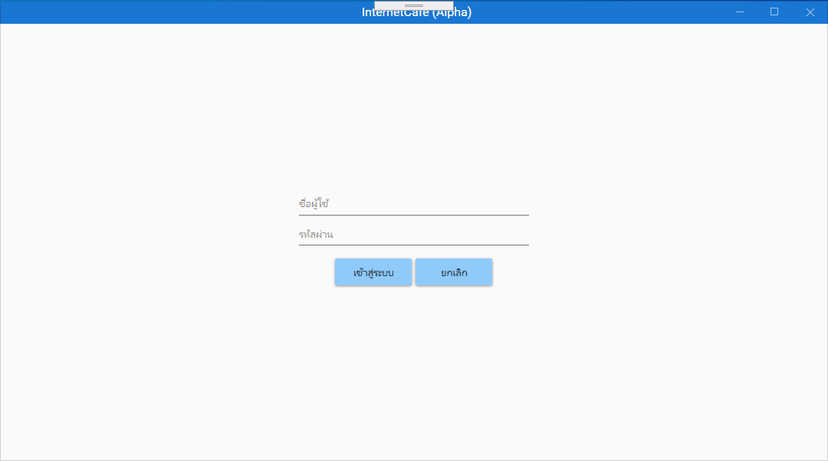

- กรณีไม่ระบุข้อมูล หรือระบุข้อมูลไม่ครบ

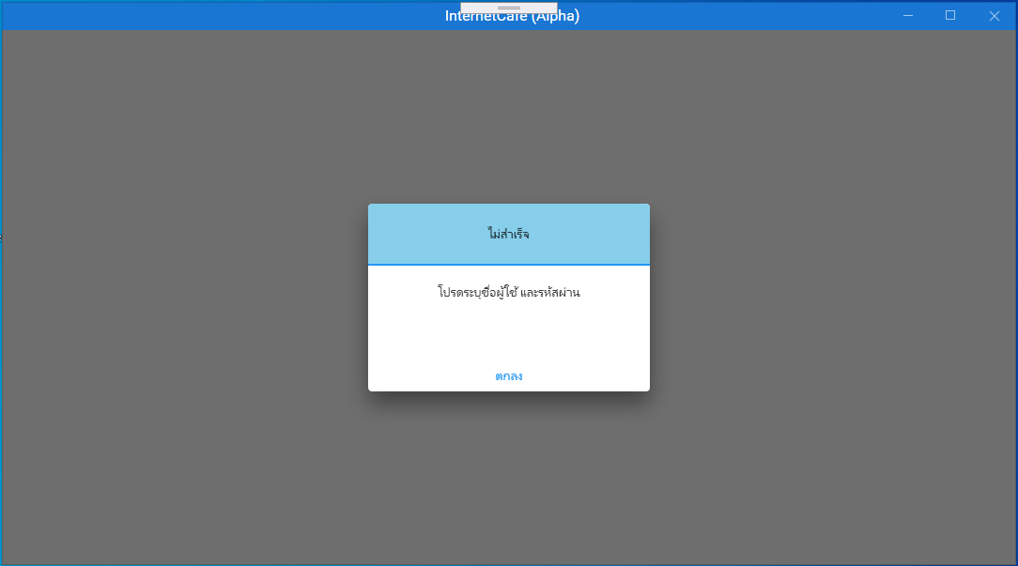

- กรณีชื่อผู้ใช้หรือรหัสผ่านไม่ถูกต้อง

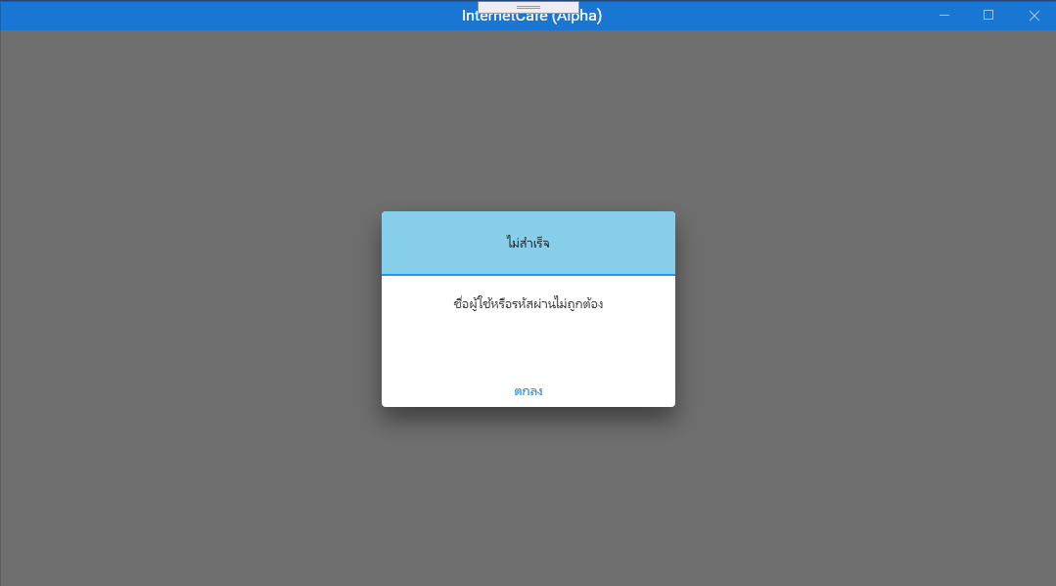

- กรณีหมดอายุการใช้งาน

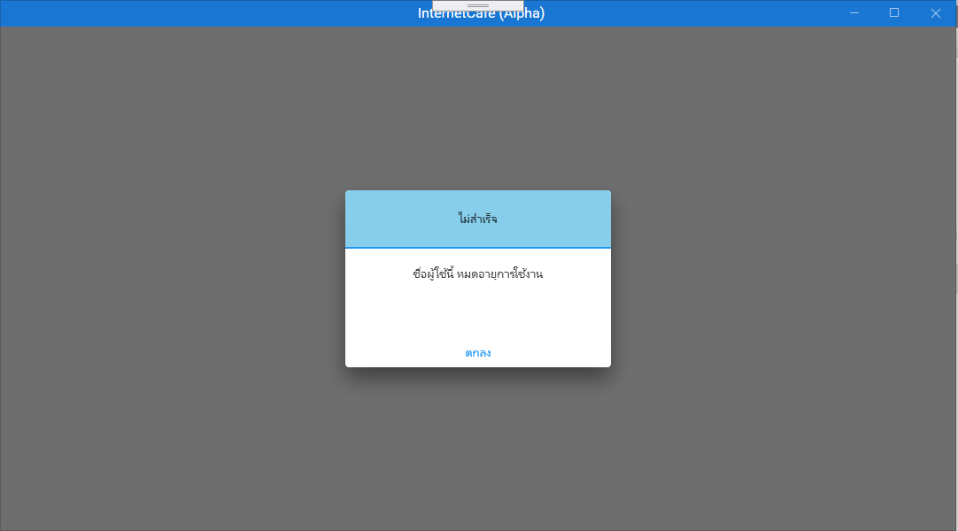

- กรณีการเชื่อมต่อผิดพลาด

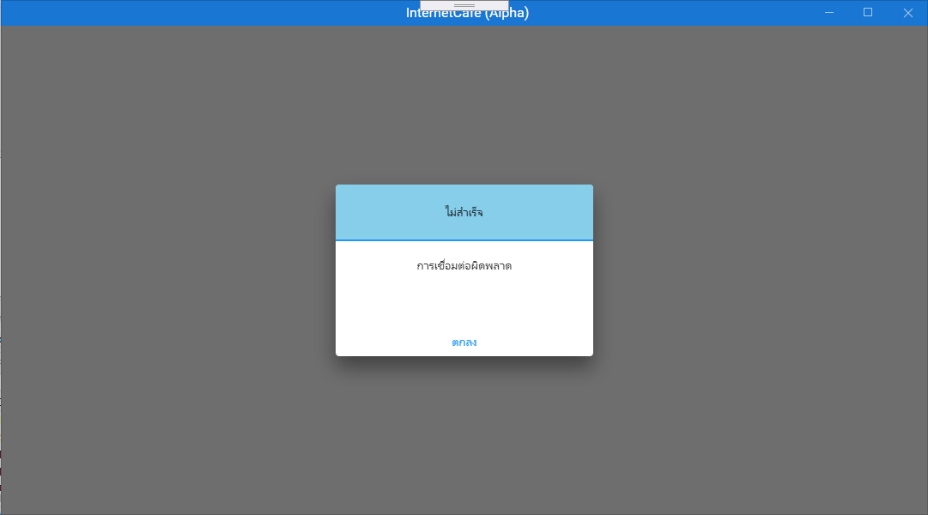

- กรณีกดปุ่มยกเลิก

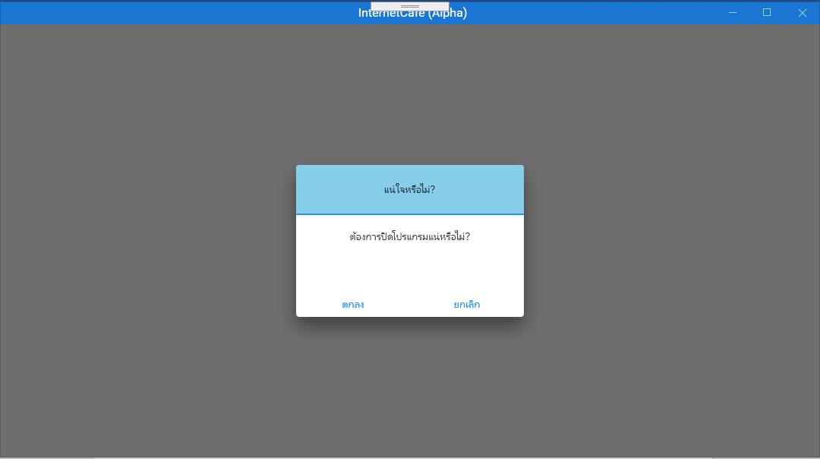

#region Constructor

public LoginViewModel()

{

pass = new RelayCommand(p=> GoPassChanged(p));

btn_login = new RelayCommand(p =>

{

if (txt_username == null || txt_password == null ||

txt_username == "" || txt_password == "")

{

IoC.WarningView.msg_title = GetLocalizedValue<string>("title_false");

IoC.WarningView.msg_text = GetLocalizedValue<string>("enter_user_pass");

DialogHost.Show(new WarningView(), "Msg");

}

else

{

if (IsLoginCheck() == true && data.Rows.Count > 0)

{

login_data = data.Rows[0];

if (login_data["exp_check"].ToString() == "true")

{

if (login_data["staff_s_date"].ToString() == "" &&

login_data["type_name"].ToString() != "admin")

{

if (IsUpdate() == true)

{

GoToMain();

}

}

else

{

GoToMain();

}

}

else

{

IoC.WarningView.msg_title = GetLocalizedValue<string>("title_false");

IoC.WarningView.msg_text = GetLocalizedValue<string>("user_expire");

DialogHost.Show(new WarningView(), "Msg");

}

}

else if (IsLoginCheck() == true && data.Rows.Count < 1)

{

IoC.WarningView.msg_title = GetLocalizedValue<string>("title_false");

IoC.WarningView.msg_text = GetLocalizedValue<string>("unsuccess");

DialogHost.Show(new WarningView(), "Msg");

IoC.Application.CurrPage = ApplicationPage.Reset;

IoC.Application.CurrPage = ApplicationPage.Login;

}

}

});

btn_cancel = new RelayCommand(p =>

{

IoC.ConfirmView.msg_title = GetLocalizedValue<string>("title_confirm");

IoC.ConfirmView.msg_text = GetLocalizedValue<string>("cancel_confirm");

DialogHost.Show(new ConfirmView(), "Msg", ConfirmClosingEventHandler);

});

}

#endregion

#region other method

public void GoToMain()

{

username = login_data["staff_username"].ToString();

login_id = login_data["staff_id"].ToString();

IoC.MainView.btn_control.Execute("");

IoC.Application.list_menu = true;

IoC.Application.CurrPage = ApplicationPage.Reset;

IoC.Application.CurrPage = ApplicationPage.Main;

if (login_data["type_name"].ToString() == "staff")

{

IoC.OptionView.admin_check = false;

IoC.OptionView.user_group_check = false;

IoC.OptionView.promotion_check = false;

IoC.StaffView.add_check = false;

IoC.StaffView.del_check = false;

IoC.GenerateCouponView.option_coupon_check = false;

}

}

public bool IsLoginCheck()

{

string query = $"select *,if(staff_e_date is null or staff_e_date >= current_timestamp(),'true','false') as exp_check " +

$"from staff " +

$"left join user_group on user_group.group_id = staff.group_id " +

$"left join type on type.type_id = user_group.type_id " +

$"where staff_username = '{txt_username}' and staff_password = '{txt_password}' ";

try

{

if (OpenConnection() == true)

{

MySqlCommand cmd = new MySqlCommand(query, Sconn.conn);

MySqlDataAdapter adp = new MySqlDataAdapter(cmd);

DataTable dt = new DataTable();

adp.Fill(dt);

data = dt;

Sconn.conn.Close();

return true;

}

else

{

Sconn.conn.Close();

return false;

}

}

catch (MySqlException ex)

{

Sconn.conn.Close();

if (ex.Number == 0)

{

IoC.WarningView.msg_title = GetLocalizedValue<string>("title_false");

IoC.WarningView.msg_text = GetLocalizedValue<string>("conn_unsuccess");

DialogHost.Show(new WarningView(), "Msg");

}

else

{

IoC.WarningView.msg_title = GetLocalizedValue<string>("title_false");

IoC.WarningView.msg_text = GetLocalizedValue<string>("conn_unsuccess");

DialogHost.Show(new WarningView(), "Msg");

}

return false;

}

}

public bool IsUpdate()

{

string query = $"update staff set " +

$"staff_s_date = '{DateTime.Now.ToString("yyyy-MM-dd HH:mm:ss", new CultureInfo("us-US", false))}' " +

$"where staff_id = '{login_data["staff_id"].ToString()}' ";

try

{

if (OpenConnection() == true)

{

MySqlCommand cmd = new MySqlCommand(query, Sconn.conn);

MySqlDataReader reader = cmd.ExecuteReader();

reader.Close();

Sconn.conn.Close();

return true;

}

else

{

Sconn.conn.Close();

return false;

}

}

catch (MySqlException ex)

{

Sconn.conn.Close();

if (ex.Number == 0)

{

IoC.WarningView.msg_title = GetLocalizedValue<string>("title_false");

IoC.WarningView.msg_text = GetLocalizedValue<string>("conn_unsuccess");

DialogHost.Show(new WarningView(), "Msg");

}

else

{

IoC.WarningView.msg_title = GetLocalizedValue<string>("title_false");

IoC.WarningView.msg_text = GetLocalizedValue<string>("conn_unsuccess");

DialogHost.Show(new WarningView(), "Msg");

}

return false;

}

}

public void ConfirmClosingEventHandler(object sender, DialogClosingEventArgs eventArgs)

{

if ((bool)eventArgs.Parameter == true)

{

Application.Current.Shutdown();

}

}

public void GoPassChanged(object p)

{

var passwordBox = p as PasswordBox;

string EncryptionKey = "test123456key";

byte[] clearBytes = Encoding.Unicode.GetBytes(passwordBox.Password);

using (Aes encryptor = Aes.Create())

{

Rfc2898DeriveBytes pdb = new Rfc2898DeriveBytes(EncryptionKey, new byte[] { 0x49, 0x76, 0x61, 0x6e, 0x20, 0x4d, 0x65, 0x64, 0x76, 0x65, 0x64, 0x65, 0x76 });

encryptor.Key = pdb.GetBytes(32);

encryptor.IV = pdb.GetBytes(16);

using (MemoryStream ms = new MemoryStream())

{

using (CryptoStream cs = new CryptoStream(ms, encryptor.CreateEncryptor(), CryptoStreamMode.Write))

{

cs.Write(clearBytes, 0, clearBytes.Length);

cs.Close();

}

txt_password = Convert.ToBase64String(ms.ToArray());

}

}

}

public bool OpenConnection()

{

try

{

Sconn.conn.Open();

return true;

}

catch (MySqlException ex)

{

Sconn.conn.Close();

if (ex.Number == 0)

{

IoC.WarningView.msg_title = GetLocalizedValue<string>("title_false");

IoC.WarningView.msg_text = GetLocalizedValue<string>("conn_unsuccess");

DialogHost.Show(new WarningView(), "Msg");

}

else

{

IoC.WarningView.msg_title = GetLocalizedValue<string>("title_false");

IoC.WarningView.msg_text = GetLocalizedValue<string>("conn_unsuccess");

DialogHost.Show(new WarningView(), "Msg");

}

return false;

}

}

public void IsClear()

{

txt_username = null;

txt_password = null;

}

public static T GetLocalizedValue<T>(string key)

{

return LocExtension.GetLocalizedValue<T>(Assembly.GetCallingAssembly().GetName().Name + ":resLang:" + key);

}

#endregion

หน้าควบคุม

- กรณีทำงานปกติ

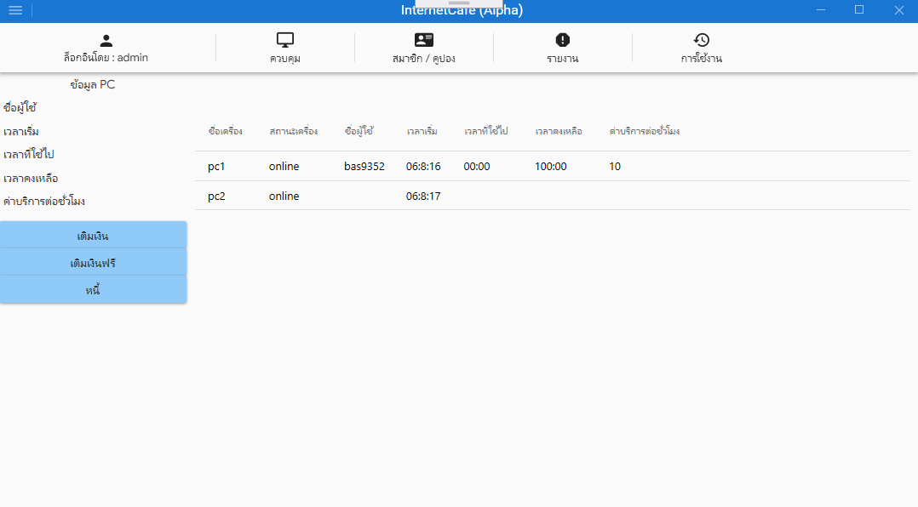

- กรณีการเชื่อมต่อผิดพลาด

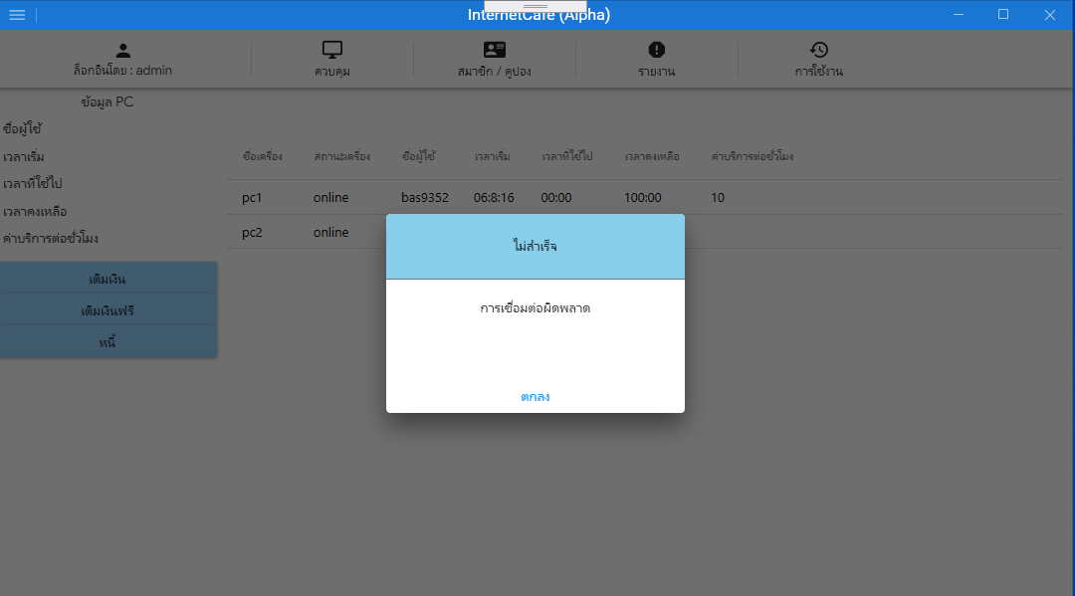

#region Constructor

public ControlViewModel()

{

item_online = new RelayCommand(p => GoItemOnline(p));

item_online_changed = new RelayCommand(p => GoItemOnlineChanged(p));

btn_top_up = new RelayCommand(p =>

{

if (online_item != null)

{

if (online_item["v_all_type_name"].ToString() == "member")

{

IoC.TopUpView.member_id = online_item["v_online_member_id"].ToString();

IoC.TopUpView.bonus_status = online_item["v_group_bonus_status"].ToString();//สถานะโบนัส เปิด หรือปิด

IoC.TopUpView.group_rate = (3600 / double.Parse(online_item["v_all_group_rate"].ToString())).ToString();//เรทราคา

IoC.TopUpView.txt_username = online_item["v_all_username"].ToString();

IoC.TopUpView.txt_total_remaining_amount = string.Format("{0:#,##0.##}", double.Parse(online_item["v_all_remaining_amount"].ToString()));//รวมเงินคงเหลือ ใช้แสดง

IoC.TopUpView.remaining_money = online_item["v_all_remaining_amount"].ToString();//เงินคงเหลือ รวมจากเงินจริงและฟรี

IoC.TopUpView.seconds = (double.Parse(IoC.TopUpView.group_rate) * double.Parse(IoC.TopUpView.remaining_money)).ToString();

IoC.TopUpView.txt_remaining_hh = string.Format("{0:0}" + " h", Math.Floor(double.Parse(IoC.TopUpView.seconds) / 3600));

IoC.TopUpView.txt_remaining_mm = string.Format("{0:0}" + " m", Math.Round((double.Parse(IoC.TopUpView.seconds) / 60) % 60));

IoC.TopUpView.ordinal = int.Parse(online_item["v_all_ordinal_last"].ToString());

DialogHost.Show(new TopUpView(), "Main");

}

else if (online_item["v_all_type_name"].ToString() == "coupon")

{

IoC.TopUpView.coupon_id = online_item["v_online_coupon_id"].ToString();

IoC.TopUpView.bonus_status = "false";

IoC.TopUpView.group_rate = (3600 / double.Parse(online_item["v_all_group_rate"].ToString())).ToString();//เรทราคา

IoC.TopUpView.txt_username = online_item["v_all_username"].ToString();

IoC.TopUpView.txt_total_remaining_amount = string.Format("{0:#,##0.##}", double.Parse(online_item["v_all_remaining_amount"].ToString()));//รวมเงินคงเหลือ ใช้แสดง

IoC.TopUpView.remaining_money = online_item["v_all_remaining_amount"].ToString();//เงินคงเหลือ รวมจากเงินจริงและฟรี

IoC.TopUpView.seconds = (double.Parse(IoC.TopUpView.group_rate) * double.Parse(IoC.TopUpView.remaining_money)).ToString();

IoC.TopUpView.txt_remaining_hh = string.Format("{0:0}" + " h", Math.Floor(double.Parse(IoC.TopUpView.seconds) / 3600));

IoC.TopUpView.txt_remaining_mm = string.Format("{0:0}" + " m", Math.Round((double.Parse(IoC.TopUpView.seconds) / 60) % 60));

IoC.TopUpView.ordinal = int.Parse(online_item["v_all_ordinal_last"].ToString());

DialogHost.Show(new TopUpView(), "Main");

}

else

{

IoC.WarningView.msg_title = GetLocalizedValue<string>("title_false");

IoC.WarningView.msg_text = GetLocalizedValue<string>("not_group_can_top_up");

DialogHost.Show(new WarningView(), "Msg");

}

}

else

{

IoC.WarningView.msg_title = GetLocalizedValue<string>("title_false");

IoC.WarningView.msg_text = GetLocalizedValue<string>("enter_info");

DialogHost.Show(new WarningView(), "Msg");

}

});

btn_free_top_up = new RelayCommand(p =>

{

if (online_item != null)

{

if (online_item["v_all_type_name"].ToString() == "member")

{

IoC.FreeTopUpView.member_id = online_item["v_online_member_id"].ToString();

IoC.FreeTopUpView.group_rate = (3600 / double.Parse(online_item["v_all_group_rate"].ToString())).ToString();

IoC.FreeTopUpView.remaining_free_money = online_item["v_all_remaining_free_amount"].ToString();//เงินฟรีคงเหลือ

IoC.FreeTopUpView.txt_username = online_item["v_all_username"].ToString();

IoC.FreeTopUpView.txt_total_remaining_amount = string.Format("{0:#,##0.##}", double.Parse(online_item["v_all_remaining_amount"].ToString()));//รวมเงินคงเหลือ ใช้แสดง

IoC.FreeTopUpView.remaining_money = online_item["v_all_remaining_amount"].ToString();//เงินคงเหลือ รวมจากเงินจริงและฟรี

IoC.FreeTopUpView.seconds = (double.Parse(IoC.FreeTopUpView.group_rate) * double.Parse(IoC.FreeTopUpView.remaining_money)).ToString();

IoC.FreeTopUpView.txt_remaining_hh = string.Format("{0:0}" + " h", Math.Floor(double.Parse(IoC.FreeTopUpView.seconds) / 3600));

IoC.FreeTopUpView.txt_remaining_mm = string.Format("{0:0}" + " m", Math.Round((double.Parse(IoC.FreeTopUpView.seconds) / 60) % 60));

IoC.FreeTopUpView.ordinal = int.Parse(online_item["v_all_ordinal_last"].ToString());

DialogHost.Show(new FreeTopUpView(), "Main");

}

else if (online_item["v_all_type_name"].ToString() == "coupon")

{

IoC.FreeTopUpView.coupon_id = online_item["v_online_coupon_id"].ToString();

IoC.FreeTopUpView.group_rate = (3600 / double.Parse(online_item["v_all_group_rate"].ToString())).ToString();

IoC.FreeTopUpView.remaining_free_money = online_item["v_all_remaining_free_amount"].ToString();//เงินฟรีคงเหลือ

IoC.FreeTopUpView.txt_username = online_item["v_all_username"].ToString();

IoC.FreeTopUpView.txt_total_remaining_amount = string.Format("{0:#,##0.##}", double.Parse(online_item["v_all_remaining_amount"].ToString()));//รวมเงินคงเหลือ ใช้แสดง

IoC.FreeTopUpView.remaining_money = online_item["v_all_remaining_amount"].ToString();//เงินคงเหลือ รวมจากเงินจริงและฟรี

IoC.FreeTopUpView.seconds = (double.Parse(IoC.FreeTopUpView.group_rate) * double.Parse(IoC.FreeTopUpView.remaining_money)).ToString();

IoC.FreeTopUpView.txt_remaining_hh = string.Format("{0:0}" + " h", Math.Floor(double.Parse(IoC.FreeTopUpView.seconds) / 3600));

IoC.FreeTopUpView.txt_remaining_mm = string.Format("{0:0}" + " m", Math.Round((double.Parse(IoC.FreeTopUpView.seconds) / 60) % 60));

IoC.FreeTopUpView.ordinal = int.Parse(online_item["v_all_ordinal_last"].ToString());

DialogHost.Show(new FreeTopUpView(), "Main");

}

else

{

IoC.WarningView.msg_title = GetLocalizedValue<string>("title_false");

IoC.WarningView.msg_text = GetLocalizedValue<string>("not_group_can_top_up");

DialogHost.Show(new WarningView(), "Msg");

}

}

else

{

IoC.WarningView.msg_title = GetLocalizedValue<string>("title_false");

IoC.WarningView.msg_text = GetLocalizedValue<string>("enter_info");

DialogHost.Show(new WarningView(), "Msg");

}

});

btn_debt = new RelayCommand(p =>

{

if (online_item != null)

{

if (online_item["v_all_type_name"].ToString() == "member")

{

IoC.DebtView.CurrPage = ApplicationPage.Lend;

//เพิ่มหนี้

IoC.LendView.member_id = online_item["v_online_member_id"].ToString();

IoC.LendView.group_rate = (3600 / double.Parse(online_item["v_all_group_rate"].ToString())).ToString();

IoC.LendView.txt_total_remaining_amount = string.Format("{0:#,##0.##}", double.Parse(online_item["v_all_remaining_amount"].ToString()));//รวมเงินคงเหลือ ใช้แสดง

IoC.LendView.remaining_money = online_item["v_all_remaining_amount"].ToString();//เงินคงเหลือ รวมจากเงินจริงและฟรี

IoC.LendView.txt_credit_limit = online_item["v_member_credit_limit"].ToString();//ยืมได้ไม่เกิน

IoC.LendView.txt_username = online_item["v_all_username"].ToString();

IoC.LendView.txt_debt = online_item["v_member_total_debt_remaining_amount"].ToString();

IoC.LendView.member_seconds = (double.Parse(IoC.LendView.group_rate) * double.Parse(IoC.LendView.remaining_money)).ToString();

IoC.LendView.txt_remaining_hh = string.Format("{0:0}" + " h", Math.Floor(double.Parse(IoC.LendView.member_seconds) / 3600));

IoC.LendView.txt_remaining_mm = string.Format("{0:0}" + " m", Math.Round((double.Parse(IoC.LendView.member_seconds) / 60) % 60));

IoC.LendView.ordinal = int.Parse(online_item["v_all_ordinal"].ToString());

//ชำระหนี้

IoC.PayDebtView.member_id = online_item["v_online_member_id"].ToString();

IoC.PayDebtView.txt_username = online_item["v_all_username"].ToString();

IoC.PayDebtView.txt_debt = online_item["v_member_total_debt_remaining_amount"].ToString();

IoC.PayDebtView.ordinal = int.Parse(online_item["v_all_ordinal"].ToString());

DialogHost.Show(new DebtView(), "Main");

}

else

{

IoC.WarningView.msg_title = GetLocalizedValue<string>("title_false");

IoC.WarningView.msg_text = GetLocalizedValue<string>("not_group_can_top_up");

DialogHost.Show(new WarningView(), "Msg");

}

}

else

{

IoC.WarningView.msg_title = GetLocalizedValue<string>("title_false");

IoC.WarningView.msg_text = GetLocalizedValue<string>("enter_info");

DialogHost.Show(new WarningView(), "Msg");

}

});

online_timer.Interval = new TimeSpan(0, 0, 0, 0, 5000);

online_timer.Tick += online_timer_tick;

online_timer.Start();

}

#endregion

#region other method

private void online_timer_tick(object sender, EventArgs e)

{

if (IoC.MainView.CurrPage == ApplicationPage.Control)

{

if (online_data != null)

{

lab_username = null;

lab_start_time = null;

lab_use_time = null;

lab_remaining_time = null;

lab_group_rate = null;

item_online.Execute(online_data);

}

}

else

{

online_timer.Stop();

}

}

private void GoItemOnline(object p)

{

IsClear();

online_data = p as DataGrid;

string query = $"select * " +

$"from v_computer_status";

try

{

if (OpenConnection() == true)

{

MySqlCommand cmd = new MySqlCommand(query, Sconn.conn);

MySqlDataAdapter adp = new MySqlDataAdapter(cmd);

DataTable dt = new DataTable();

adp.Fill(dt);

Sconn.conn.Close();

dt.Columns.Add("v_all_remaining_time", typeof(string));

dt.Columns.Add("v_all_use_remaining_time", typeof(string));

dt.Columns.Add("new_v_group_rate", typeof(string));

foreach (DataRow data in dt.Rows)

{

data["v_all_remaining_time"] = string.Format("{0:00:}{1:00}", data["v_all_hr"], data["v_all_mn"]);

data["v_all_use_remaining_time"] = string.Format("{0:00:}{1:00}", data["v_all_use_hr"], data["v_all_use_mn"]);

data["new_v_group_rate"] = string.Format("{0:#,##0.##}", data["v_all_group_rate"]);

}

online_data.ItemsSource = dt.DefaultView;

}

else

{

Sconn.conn.Close();

}

}

catch (MySqlException ex)

{

Sconn.conn.Close();

if (ex.Number == 0)

{

IoC.WarningView.msg_title = GetLocalizedValue<string>("title_false");

IoC.WarningView.msg_text = GetLocalizedValue<string>("conn_unsuccess");

DialogHost.Show(new WarningView(), "Msg");

}

else

{

IoC.WarningView.msg_title = GetLocalizedValue<string>("title_false");

IoC.WarningView.msg_text = GetLocalizedValue<string>("conn_unsuccess");

DialogHost.Show(new WarningView(), "Msg");

}

}

}

private void GoItemOnlineChanged(object p)

{

var item = p as DataGrid;

online_item = item.SelectedItem as DataRowView;

online_index = item.SelectedIndex;

Task.Factory.StartNew(async () =>

{

online_timer.Stop();

lab_username = online_item["v_all_username"].ToString();

lab_start_time = online_item["v_online_s_time"].ToString();

lab_use_time = online_item["v_all_use_remaining_time"].ToString();

lab_remaining_time = online_item["v_all_remaining_time"].ToString();

lab_group_rate = online_item["new_v_group_rate"].ToString();

await Task.Delay(15000);

}).ContinueWith((previousTask) => {

online_timer.Start();

}, TaskScheduler.FromCurrentSynchronizationContext());

}

public void IsClear()

{

online_item = null;

online_index = 0;

}

private bool OpenConnection()

{

try

{

Sconn.conn.Open();

return true;

}

catch (MySqlException ex)

{

Sconn.conn.Close();

if (ex.Number == 0)

{

IoC.WarningView.msg_title = GetLocalizedValue<string>("title_false");

IoC.WarningView.msg_text = GetLocalizedValue<string>("conn_unsuccess");

DialogHost.Show(new WarningView(), "Msg");

}

else

{

IoC.WarningView.msg_title = GetLocalizedValue<string>("title_false");

IoC.WarningView.msg_text = GetLocalizedValue<string>("conn_unsuccess");

DialogHost.Show(new WarningView(), "Msg");

}

return false;

}

}

public static T GetLocalizedValue<T>(string key)

{

return LocExtension.GetLocalizedValue<T>(Assembly.GetCallingAssembly().GetName().Name + ":resLang:" + key);

}

#endregion

หน้าเติมเงินจริง

- กรณีไม่ระบุข้อมูล

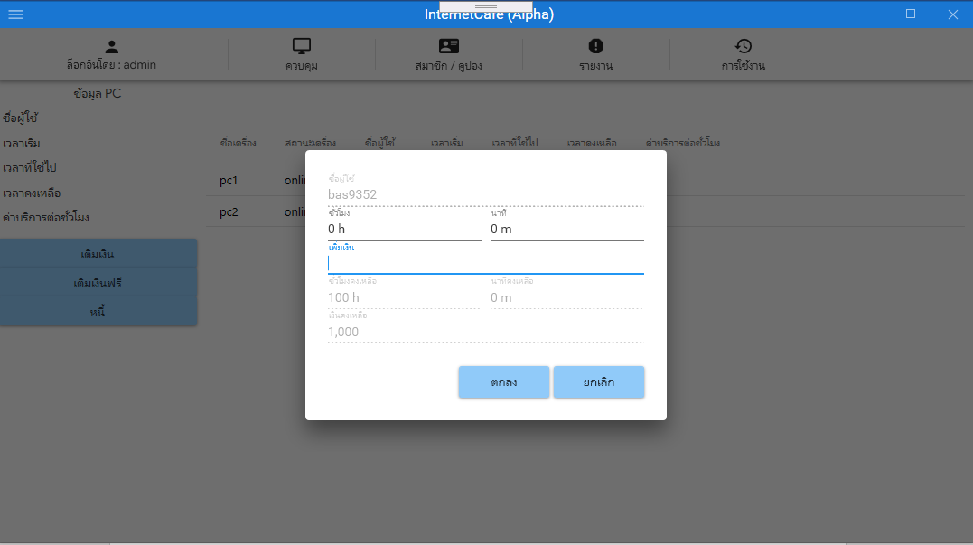

- กรณีไม่ระบุข้อมูล หรือระบุข้อมูลไม่ครบ

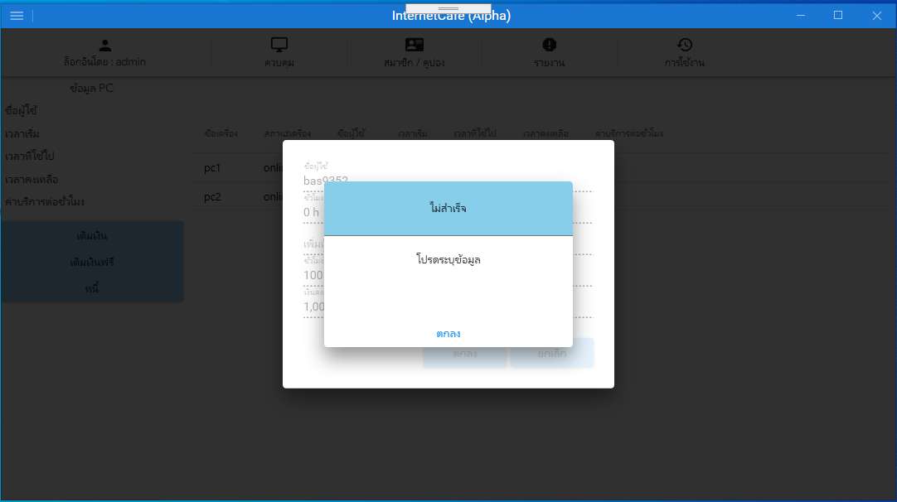

กรณีการเชื่อมต่อผิดพลาด

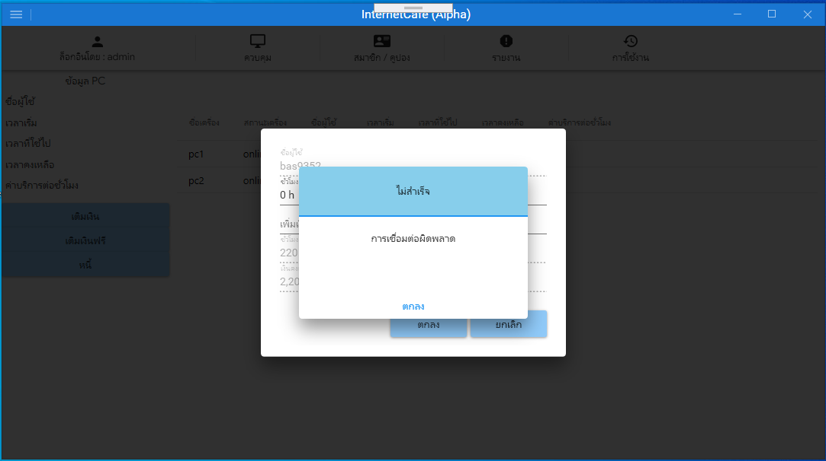

#region Constructor

public TopUpViewModel()

{

add_money_change = new RelayCommand(p => GoAddMoneyChanged(p));

add_hh_change = new RelayCommand(p => GoAddHHChanged(p));

add_mm_change = new RelayCommand(p => GoAddMMChanged(p));

btn_ok = new RelayCommand(p=>

{

grid_top_up_check = false;

if (txt_add_money == null || txt_add_money == "")

{

IoC.WarningView.msg_title = GetLocalizedValue<string>("title_false");

IoC.WarningView.msg_text = GetLocalizedValue<string>("enter_info");

DialogHost.Show(new WarningView(), "Msg", ConfirmClosingEventHandler);

}

else

{

if (bonus_status == "false")

{

if (IsInsert() == true)

{

IoC.WarningView.msg_title = GetLocalizedValue<string>("title_success");

IoC.WarningView.msg_text = GetLocalizedValue<string>("add_success");

DialogHost.Show(new WarningView(), "Msg", ExtendedClosingEventHandler);

}

}

else

{

if (IsSelect() == true)

{

int num = 0;

for (int i = 0; i < data.Rows.Count; i++)

{

DataRow row = data.Rows[i];

if (row["bonus_top_up"].ToString() == txt_add_money)

{

num = 1;

bonus_id = row["bonus_id"].ToString();

if (IsInsert() == true)

{

IoC.WarningView.msg_title = GetLocalizedValue<string>("title_success");

IoC.WarningView.msg_text = GetLocalizedValue<string>("add_success");

DialogHost.Show(new WarningView(), "Msg", ExtendedClosingEventHandler);

}

}

}

if (num == 0)

{

if (IsInsert() == true)

{

IoC.WarningView.msg_title = GetLocalizedValue<string>("title_success");

IoC.WarningView.msg_text = GetLocalizedValue<string>("add_success");

DialogHost.Show(new WarningView(), "Msg", ExtendedClosingEventHandler);

}

}

}

}

}

});

btn_cancel = new RelayCommand(p =>

{

IoC.Application.DialogHostMain = false;

IsClear();

});

}

#endregion

#region other method

public bool IsSelect()

{

string query = $"select * from bonus order by bonus_id;";

try

{

if (OpenConnection() == true)

{

MySqlCommand cmd = new MySqlCommand(query, Sconn.conn);

MySqlDataAdapter adp = new MySqlDataAdapter(cmd);

DataTable dt = new DataTable();

adp.Fill(dt);

data = dt;

Sconn.conn.Close();

return true;

}

else

{

Sconn.conn.Close();

return false;

}

}

catch (MySqlException ex)

{

Sconn.conn.Close();

if (ex.Number == 0)

{

IoC.WarningView.msg_title = GetLocalizedValue<string>("title_false");

IoC.WarningView.msg_text = GetLocalizedValue<string>("conn_unsuccess");

DialogHost.Show(new WarningView(), "Msg");

}

else

{

IoC.WarningView.msg_title = GetLocalizedValue<string>("title_false");

IoC.WarningView.msg_text = GetLocalizedValue<string>("conn_unsuccess");

DialogHost.Show(new WarningView(), "Msg");

}

return false;

}

}

public void IsClear()

{

txt_username = null;

txt_add_hh = "0 h";

txt_add_mm = "0 m";

txt_add_money = null;

txt_remaining_hh = null;

txt_remaining_mm = null;

txt_total_remaining_amount = null;

}

private void ExtendedClosingEventHandler(object sender, DialogClosingEventArgs eventArgs)

{

if ((bool)eventArgs.Parameter == true)

{

grid_top_up_check = true;

IoC.Application.DialogHostMain = false;

IsClear();

if (IoC.MainView.CurrPage == ApplicationPage.Control)

{

IoC.ControlView.item_online.Execute(IoC.ControlView.online_data);

}

else if (IoC.MainView.CurrPage == ApplicationPage.MemberCoupon)

{

if (IoC.MemberCouponView.CurrPage == ApplicationPage.Member)

{

IoC.MemberView.item_member.Execute(IoC.MemberView.member_data);

}

else

{

IoC.CouponView.item_coupon.Execute(IoC.CouponView.coupon_data);

}

}

}

}

private void ConfirmClosingEventHandler(object sender, DialogClosingEventArgs eventArgs)

{

if ((bool)eventArgs.Parameter == true)

{

grid_top_up_check = true;

}

}

string query;

public bool IsInsert()

{

if (IoC.MemberCouponView.CurrPage == ApplicationPage.Member)

{

query = $"insert into member_top_up set " +

$"mt_member_id = '{member_id}', " +

$"mt_by = '{IoC.LoginView.login_id}', " +

$"mt_ordinal = '{ordinal + 1}', " +

$"mt_real_amount = '{txt_add_money}', " +

$"mt_bonus_id = '{bonus_id}', " +

$"mt_date = '{DateTime.Now.ToString("yyyy-MM-dd HH:mm:ss", new CultureInfo("us-US", false))}' ";

}

else if (IoC.MemberCouponView.CurrPage == ApplicationPage.Coupon)

{

query = $"insert into coupon_top_up set " +

$"ct_coupon_id = '{coupon_id}', " +

$"ct_by = '{IoC.LoginView.login_id}', " +

$"ct_ordinal = '{ordinal + 1}', " +

$"ct_real_amount = '{txt_add_money}', " +

$"ct_date = '{DateTime.Now.ToString("yyyy-MM-dd HH:mm:ss", new CultureInfo("us-US", false))}' ";

}

try

{

if (OpenConnection() == true)

{

MySqlCommand cmd = new MySqlCommand(query, Sconn.conn);

MySqlDataReader reader = cmd.ExecuteReader();

reader.Close();

Sconn.conn.Close();

return true;

}

else

{

Sconn.conn.Close();

return false;

}

}

catch (MySqlException ex)

{

Sconn.conn.Close();

if (ex.Number == 0)

{

IoC.WarningView.msg_title = GetLocalizedValue<string>("title_false");

IoC.WarningView.msg_text = GetLocalizedValue<string>("conn_unsuccess");

DialogHost.Show(new WarningView(), "Msg");

}

else

{

IoC.WarningView.msg_title = GetLocalizedValue<string>("title_false");

IoC.WarningView.msg_text = GetLocalizedValue<string>("conn_unsuccess");

DialogHost.Show(new WarningView(), "Msg");

}

return false;

}

}

public void GoAddHHChanged(object p)

{

var item = p as TextBox;

if (item.IsFocused)

{

if (txt_add_mm == "" || txt_add_mm == null)

{

min = "0";

}

else

{

string[] add_min = txt_add_mm.Split(" m".ToCharArray());

min = add_min[0];

}

if (txt_add_hh == "" || txt_add_hh == null)

{

hr = "0";

}

else

{

string[] add_hr = txt_add_hh.Split(" h".ToCharArray());

hr = add_hr[0];

}

txt_add_hh = string.Format("{0:0}" + " h", hr);

txt_add_mm = string.Format("{0:0}" + " m", min);

if (txt_add_hh != "" && txt_add_mm != "")

{

if (hr == "")

{

hr = "0";

}

new_seconds = ((int.Parse(hr) * 3600) + (int.Parse(min) * 60)).ToString();

txt_add_money = Math.Round((float.Parse(new_seconds) / float.Parse(group_rate)), 2).ToString();

txt_add_money = (float.Parse(new_seconds) / float.Parse(group_rate)).ToString();

}

IsChanged();

}

}

public void GoAddMMChanged(object p)

{

var item = p as TextBox;

if (item.IsFocused)

{

if (txt_add_mm == "" || txt_add_mm == null)

{

min = "0";

}

else

{

string[] add_min = txt_add_mm.Split(" m".ToCharArray());

min = add_min[0];

}

if (txt_add_hh == "" || txt_add_hh == null)

{

hr = "0";

}

else

{

string[] add_hr = txt_add_hh.Split(" h".ToCharArray());

hr = add_hr[0];

}

txt_add_hh = string.Format("{0:0}" + " h", hr);

txt_add_mm = string.Format("{0:0}" + " m", min);

if (txt_add_hh != "" && txt_add_mm != "")

{

if (min == "")

{

min = "0";

}

new_seconds = ((int.Parse(hr) * 3600) + (int.Parse(min) * 60)).ToString();

txt_add_money = Math.Round((float.Parse(new_seconds) / float.Parse(group_rate)), 2).ToString();

txt_add_money = (float.Parse(new_seconds) / float.Parse(group_rate)).ToString();

}

IsChanged();

}

}

public void GoAddMoneyChanged(object p)

{

var item = p as TextBox;

if (item.Text == null || item.Text == "")

{

txt_add_money = "";

new_seconds = (float.Parse(group_rate) * 0).ToString();

txt_add_hh = string.Format("{0:0}" + " h", Math.Floor(float.Parse(new_seconds) / 3600));

txt_add_mm = string.Format("{0:0}" + " m", Math.Round((float.Parse(new_seconds) / 60) % 60));

}

else

{

new_seconds = (float.Parse(group_rate) * float.Parse(txt_add_money)).ToString();

txt_add_hh = string.Format("{0:0}" + " h", Math.Floor(float.Parse(new_seconds) / 3600));

txt_add_mm = string.Format("{0:0}" + " m", Math.Round((float.Parse(new_seconds) / 60) % 60));

}

IsChanged();

}

public void IsChanged()

{

var member_total_seconds = float.Parse(new_seconds) + float.Parse(seconds);

txt_remaining_hh = string.Format("{0:0}" + " h", Math.Floor(member_total_seconds / 3600));

txt_remaining_mm = string.Format("{0:0}" + " m", Math.Round((member_total_seconds / 60) % 60));

if (txt_add_money == "")

{

txt_total_remaining_amount = string.Format("{0:#,##0.##}", float.Parse(remaining_money));

}

else

{

txt_total_remaining_amount = string.Format("{0:#,##0.##}", float.Parse(remaining_money) + float.Parse(txt_add_money));

}

}

public bool OpenConnection()

{

try

{

Sconn.conn.Open();

return true;

}

catch (MySqlException ex)

{

Sconn.conn.Close();

if (ex.Number == 0)

{

IoC.WarningView.msg_title = GetLocalizedValue<string>("title_false");

IoC.WarningView.msg_text = GetLocalizedValue<string>("conn_unsuccess");

DialogHost.Show(new WarningView(), "Msg");

}

else

{

IoC.WarningView.msg_title = GetLocalizedValue<string>("title_false");

IoC.WarningView.msg_text = GetLocalizedValue<string>("conn_unsuccess");

DialogHost.Show(new WarningView(), "Msg");

}

return false;

}

}

public static T GetLocalizedValue<T>(string key)

{

return LocExtension.GetLocalizedValue<T>(Assembly.GetCallingAssembly().GetName().Name + ":resLang:" + key);

}

#endregion

หน้าเติมเงินฟรี

- กรณีไม่ระบุข้อมูล

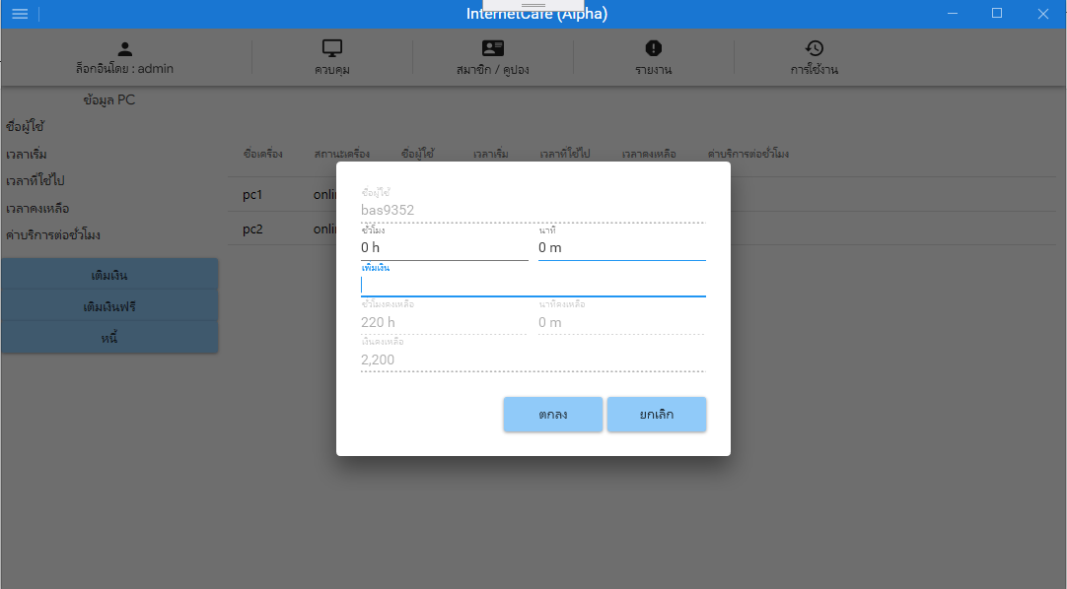

- กรณีไม่ระบุข้อมูล หรือระบุข้อมูลไม่ครบ

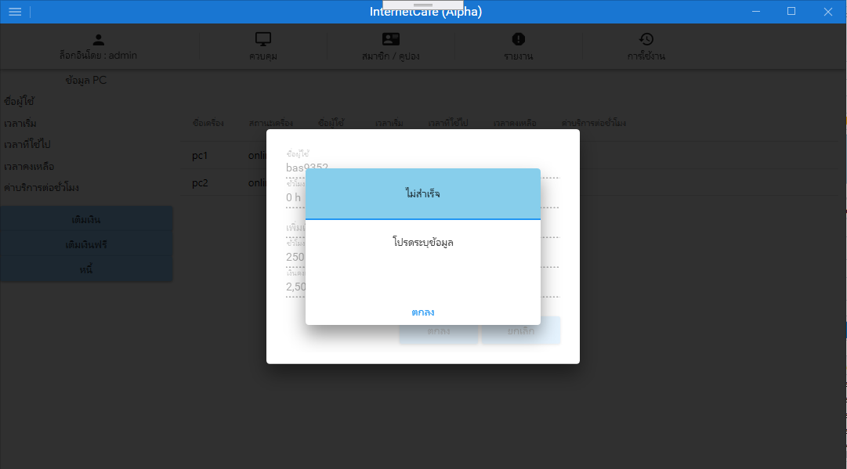

กรณีการเชื่อมต่อผิดพลาด



#region Constructor

public FreeTopUpViewModel()

{

add_money_change = new RelayCommand(p => GoAddMoneyChanged(p));

add_hh_change = new RelayCommand(p => GoAddHHChanged(p));

add_mm_change = new RelayCommand(p => GoAddMMChanged(p));

btn_ok = new RelayCommand(p =>

{

grid_add_free_check = false;

if (txt_add_money == null || txt_add_money == "")

{

IoC.WarningView.msg_title = GetLocalizedValue<string>("title_false");

IoC.WarningView.msg_text = GetLocalizedValue<string>("enter_user_pass");

DialogHost.Show(new WarningView(), "Msg", ConfirmClosingEventHandler);

}

else

{

if (IsInsert() == true)

{

IoC.WarningView.msg_title = GetLocalizedValue<string>("title_success");

IoC.WarningView.msg_text = GetLocalizedValue<string>("add_success");

DialogHost.Show(new WarningView(), "Msg", ExtendedClosingEventHandler);

}

}

});

btn_cancel = new RelayCommand(p=>

{

IoC.Application.DialogHostMain = false;

IsClear();

});

}

#endregion

#region other method

public void IsClear()

{

txt_username = null;

txt_add_hh = "0 h";

txt_add_mm = "0 m";

txt_add_money = null;

txt_remaining_hh = null;

txt_remaining_mm = null;

txt_total_remaining_amount = null;

}

private void ExtendedClosingEventHandler(object sender, DialogClosingEventArgs eventArgs)

{

if ((bool)eventArgs.Parameter == true)

{

grid_add_free_check = true;

IoC.Application.DialogHostMain = false;

IsClear();

if (IoC.MainView.CurrPage == ApplicationPage.Control)

{

IoC.ControlView.item_online.Execute(IoC.ControlView.online_data);

}

else if(IoC.MainView.CurrPage == ApplicationPage.MemberCoupon)

{

if (IoC.MemberCouponView.CurrPage == ApplicationPage.Member)

{

IoC.MemberView.item_member.Execute(IoC.MemberView.member_data);

}

else if (IoC.MemberCouponView.CurrPage == ApplicationPage.Coupon)

{

IoC.CouponView.item_coupon.Execute(IoC.CouponView.coupon_data);

}

}

}

}

private void ConfirmClosingEventHandler(object sender, DialogClosingEventArgs eventArgs)

{

if ((bool)eventArgs.Parameter == true)

{

grid_add_free_check = true;

}

}

string query;

public bool IsInsert()

{

if (IoC.MemberCouponView.CurrPage == ApplicationPage.Member)

{

query = $"insert into member_top_up set " +

$"mt_member_id = '{member_id}', " +

$"mt_by = '{IoC.LoginView.login_id}', " +

$"mt_ordinal = '{ordinal + 1}', " +

$"mt_free_amount = '{txt_add_money}', " +

$"mt_date = '{DateTime.Now.ToString("yyyy-MM-dd HH:mm:ss", new CultureInfo("us-US", false))}' ";

}

else if(IoC.MemberCouponView.CurrPage == ApplicationPage.Coupon)

{

query = $"insert into coupon_top_up set" +

$"ct_coupon_id = '{coupon_id}', " +

$"ct_by = '{IoC.LoginView.login_id}', " +

$"ct_ordinal = '{ordinal + 1}', " +

$"ct_free_amount = '{txt_add_money}', " +

$"ct_date = '{DateTime.Now.ToString("yyyy-MM-dd HH:mm:ss", new CultureInfo("us-US", false))}' ";

}

try

{

if (OpenConnection() == true)

{

MySqlCommand cmd = new MySqlCommand(query, Sconn.conn);

MySqlDataReader reader = cmd.ExecuteReader();

reader.Close();

Sconn.conn.Close();

return true;

}

else

{

Sconn.conn.Close();

return false;

}

}

catch (MySqlException ex)

{

Sconn.conn.Close();

if (ex.Number == 0)

{

IoC.WarningView.msg_title = GetLocalizedValue<string>("title_false");

IoC.WarningView.msg_text = GetLocalizedValue<string>("conn_unsuccess");

DialogHost.Show(new WarningView(), "Msg");

}

else

{

IoC.WarningView.msg_title = GetLocalizedValue<string>("title_false");

IoC.WarningView.msg_text = GetLocalizedValue<string>("conn_unsuccess");

DialogHost.Show(new WarningView(), "Msg");

}

return false;

}

}

public void GoAddHHChanged(object p)

{

var item = p as TextBox;

if (item.IsFocused)

{

if (txt_add_mm == "" || txt_add_mm == null)

{

min = "0";

}

else

{

string[] add_min = txt_add_mm.Split(" m".ToCharArray());

min = add_min[0];

}

if (txt_add_hh == "" || txt_add_hh == null)

{

hr = "0";

}

else

{

string[] add_hr = txt_add_hh.Split(" h".ToCharArray());

hr = add_hr[0];

}

txt_add_hh = string.Format("{0:0}" + " h", hr);

txt_add_mm = string.Format("{0:0}" + " m", min);

if (txt_add_hh != "" && txt_add_mm != "")

{

if (hr == "")

{

hr = "0";

}

new_seconds = ((int.Parse(hr) * 3600) + (int.Parse(min) * 60)).ToString();

txt_add_money = (float.Parse(new_seconds) / float.Parse(group_rate)).ToString();

}

IsChanged();

}

}

public void GoAddMMChanged(object p)

{

var item = p as TextBox;

if (item.IsFocused)

{

if (txt_add_mm == "" || txt_add_mm == null)

{

min = "0";

}

else

{

string[] add_min = txt_add_mm.Split(" m".ToCharArray());

min = add_min[0];

}

if (txt_add_hh == "" || txt_add_hh == null)

{

hr = "0";

}

else

{

string[] add_hr = txt_add_hh.Split(" h".ToCharArray());

hr = add_hr[0];

}

txt_add_hh = string.Format("{0:0}" + " h", hr);

txt_add_mm = string.Format("{0:0}" + " m", min);

if (txt_add_hh != "" && txt_add_mm != "")

{

if (min == "")

{

min = "0";

}

new_seconds = ((int.Parse(hr) * 3600) + (int.Parse(min) * 60)).ToString();

txt_add_money = (float.Parse(new_seconds) / float.Parse(group_rate)).ToString();

}

IsChanged();

}

}

public void GoAddMoneyChanged(object p)

{

var item = p as TextBox;

if (item.IsFocused == true && item.Text == null || item.Text == "")

{

txt_add_money = "";

new_seconds = (float.Parse(group_rate) * 0).ToString();

txt_add_hh = string.Format("{0:0}" + " h", Math.Floor(float.Parse(new_seconds) / 3600));

txt_add_mm = string.Format("{0:0}" + " m", Math.Round((float.Parse(new_seconds) / 60) % 60));

}

else if (item.IsFocused == true && item.Text != "" || item.Text != null)

{

new_seconds = (float.Parse(group_rate) * float.Parse(txt_add_money)).ToString();

txt_add_hh = string.Format("{0:0}" + " h", Math.Floor(float.Parse(new_seconds) / 3600));

txt_add_mm = string.Format("{0:0}" + " m", Math.Round((float.Parse(new_seconds) / 60) % 60));

}

IsChanged();

}

public void IsChanged()

{

var member_total_seconds = float.Parse(new_seconds) + float.Parse(seconds);

txt_remaining_hh = string.Format("{0:0}" + " h", Math.Floor(member_total_seconds / 3600));

txt_remaining_mm = string.Format("{0:0}" + " m", Math.Round((member_total_seconds / 60) % 60));

if (txt_add_money == "")

{

txt_total_remaining_amount = string.Format("{0:#,##0.##}", float.Parse(remaining_money));

}

else

{

txt_total_remaining_amount = string.Format("{0:#,##0.##}", float.Parse(remaining_money) + float.Parse(txt_add_money));

}

}

public bool OpenConnection()

{

try

{

Sconn.conn.Open();

return true;

}

catch (MySqlException ex)

{

Sconn.conn.Close();

if (ex.Number == 0)

{

IoC.WarningView.msg_title = GetLocalizedValue<string>("title_false");

IoC.WarningView.msg_text = GetLocalizedValue<string>("conn_unsuccess");

DialogHost.Show(new WarningView(), "Msg");

}

else

{

IoC.WarningView.msg_title = GetLocalizedValue<string>("title_false");

IoC.WarningView.msg_text = GetLocalizedValue<string>("conn_unsuccess");

DialogHost.Show(new WarningView(), "Msg");

}

return false;

}

}

public static T GetLocalizedValue<T>(string key)

{

return LocExtension.GetLocalizedValue<T>(Assembly.GetCallingAssembly().GetName().Name + ":resLang:" + key);

}

#endregion

หน้ายืมเงิน

-กรณีไม่ระบุข้อมูล

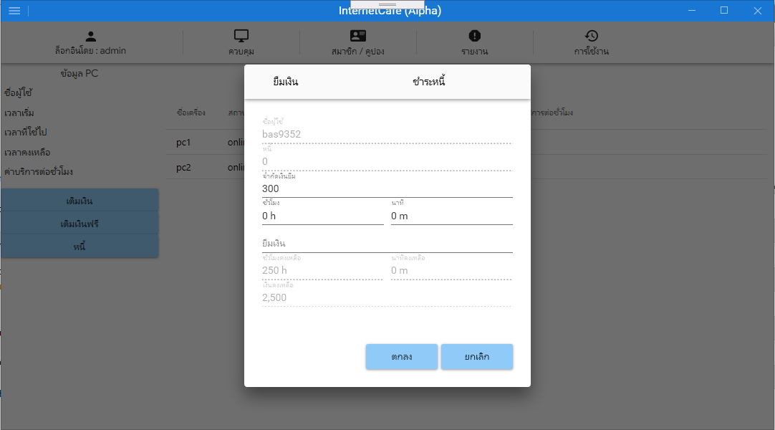

-กรณีไม่ระบุข้อมูลหรือ ระบุข้อมูลไม่ครบ

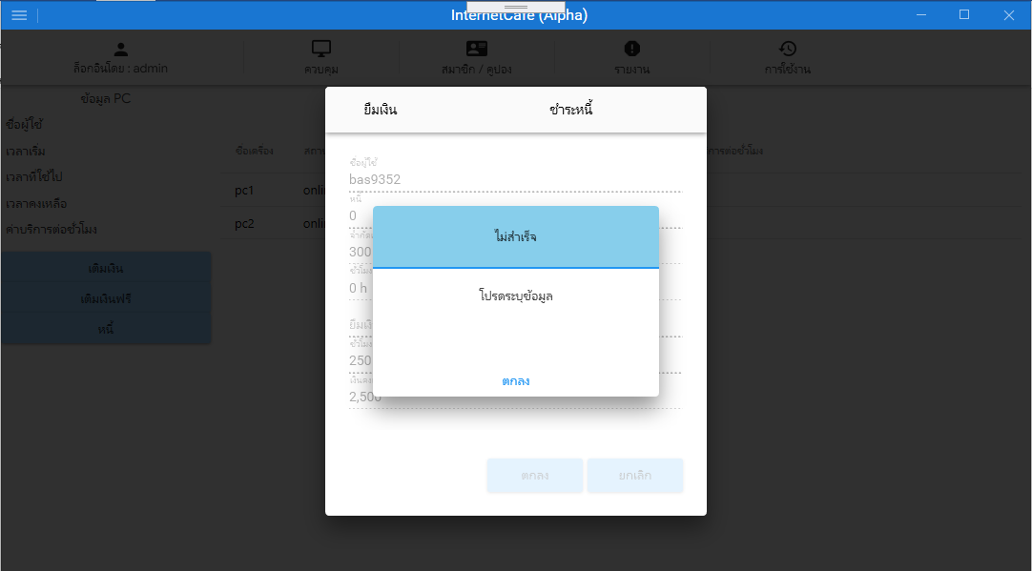

-กรณีการเชื่อมต่อผิดพลาด

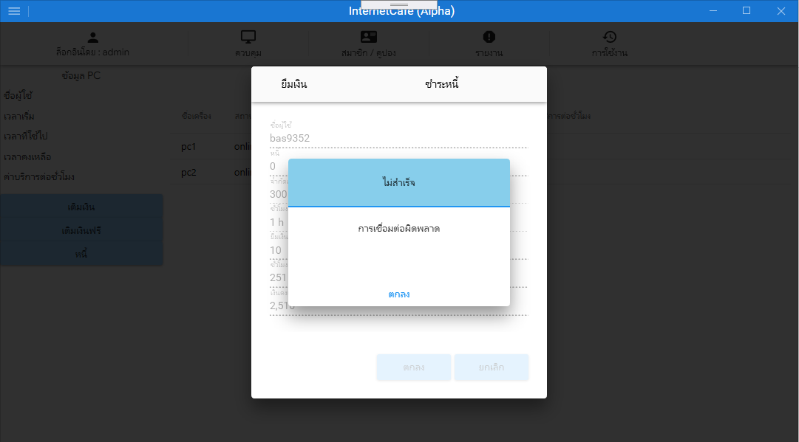

#region Constructor

public LendViewModel()

{

add_money_change = new RelayCommand(p => GoAddMoneyChanged(p));

add_hh_change = new RelayCommand(p => GoAddHHChanged(p));

add_mm_change = new RelayCommand(p => GoAddMMChanged(p));

btn_ok = new RelayCommand(p =>

{

grid_l_check = false;

if (txt_lend == null || txt_lend == "" || txt_credit_limit == null || txt_credit_limit == "")

{

IoC.WarningView.msg_title = GetLocalizedValue<string>("title_false");

IoC.WarningView.msg_text = GetLocalizedValue<string>("enter_info");

DialogHost.Show(new WarningView(), "Msg", ConfirmClosingEventHandler);

}

else

{

if (double.Parse(txt_lend) > (double.Parse(txt_credit_limit)- double.Parse(txt_debt)))

{

IoC.WarningView.msg_title = GetLocalizedValue<string>("title_false");

IoC.WarningView.msg_text = GetLocalizedValue<string>("max_credit");

DialogHost.Show(new WarningView(), "Msg", ConfirmClosingEventHandler);

}

else

{

if (IsInsert() == true)

{

IoC.WarningView.msg_title = GetLocalizedValue<string>("title_success");

IoC.WarningView.msg_text = GetLocalizedValue<string>("add_success");

DialogHost.Show(new WarningView(), "Msg", ExtendedClosingEventHandler);

}

}

}

});

btn_cancel = new RelayCommand(p =>

{

IoC.Application.DialogHostMain = false;

IsClear();

});

}

#endregion

#region other method

public void IsClear()

{

member_id = null;

txt_username = null;

txt_add_hh = "0 h";

txt_add_mm = "0 m";

txt_lend = null;

txt_remaining_hh = null;

txt_remaining_mm = null;

txt_total_remaining_amount = null;

}

private void ExtendedClosingEventHandler(object sender, DialogClosingEventArgs eventArgs)

{

if ((bool)eventArgs.Parameter == true)

{

grid_l_check = true;

IoC.Application.DialogHostMain = false;

IsClear();

if (IoC.MainView.CurrPage == ApplicationPage.Control)

{

IoC.ControlView.item_online.Execute(IoC.ControlView.online_data);

}

else if (IoC.MainView.CurrPage == ApplicationPage.MemberCoupon)

{

IoC.MemberView.item_member.Execute(IoC.MemberView.member_data);

}

}

}

private void ConfirmClosingEventHandler(object sender, DialogClosingEventArgs eventArgs)

{

if ((bool)eventArgs.Parameter == true)

{

grid_l_check = true;

}

}

public bool IsInsert()

{

string query = $"insert into member_top_up set " +

$"mt_member_id = '{member_id}', " +

$"mt_by = '{IoC.LoginView.login_id}', " +

$"mt_ordinal = '{ordinal + 1}', " +

$"mt_debt_amount = '{txt_lend}', " +

$"mt_date = '{DateTime.Now.ToString("yyyy-MM-dd HH:mm:ss", new CultureInfo("us-US", false))}'; " +

$"update member set " +

$"member_credit_limit = '{txt_credit_limit}' " +

$"where member_id = {member_id} ";

try

{

if (OpenConnection() == true)

{

MySqlCommand cmd = new MySqlCommand(query, Sconn.conn);

MySqlDataReader reader = cmd.ExecuteReader();

reader.Close();

Sconn.conn.Close();

return true;

}

else

{

Sconn.conn.Close();

return false;

}

}

catch (MySqlException ex)

{

Sconn.conn.Close();

if (ex.Number == 0)

{

IoC.WarningView.msg_title = GetLocalizedValue<string>("title_false");

IoC.WarningView.msg_text = GetLocalizedValue<string>("conn_unsuccess");

DialogHost.Show(new WarningView(), "Msg");

}

else

{

IoC.WarningView.msg_title = GetLocalizedValue<string>("title_false");

IoC.WarningView.msg_text = GetLocalizedValue<string>("conn_unsuccess");

DialogHost.Show(new WarningView(), "Msg");

}

return false;

}

}

public void GoAddHHChanged(object p)

{

var item = p as TextBox;

if (item.IsFocused)

{

if (txt_add_mm == "" || txt_add_mm == null)

{

min = "0";

}

else

{

string[] add_min = txt_add_mm.Split(" m".ToCharArray());

min = add_min[0];

}

if (txt_add_hh == "" || txt_add_hh == null)

{

hr = "0";

}

else

{

string[] add_hr = txt_add_hh.Split(" h".ToCharArray());

hr = add_hr[0];

}

txt_add_hh = string.Format("{0:0}" + " h", hr);

txt_add_mm = string.Format("{0:0}" + " m", min);

if (txt_add_hh != "" && txt_add_mm != "")

{

if (hr == "")

{

hr = "0";

}

member_new_seconds = ((int.Parse(hr) * 3600) + (int.Parse(min) * 60)).ToString();

txt_lend = (float.Parse(member_new_seconds) / float.Parse(group_rate)).ToString();

}

IsChanged();

}

}

public void GoAddMMChanged(object p)

{

var item = p as TextBox;

if (item.IsFocused)

{

if (txt_add_mm == "" || txt_add_mm == null)

{

min = "0";

}

else

{

string[] add_min = txt_add_mm.Split(" m".ToCharArray());

min = add_min[0];

}

if (txt_add_hh == "" || txt_add_hh == null)

{

hr = "0";

}

else

{

string[] add_hr = txt_add_hh.Split(" h".ToCharArray());

hr = add_hr[0];

}

txt_add_hh = string.Format("{0:0}" + " h", hr);

txt_add_mm = string.Format("{0:0}" + " m", min);

if (txt_add_hh != "" && txt_add_mm != "")

{

if (min == "")

{

min = "0";

}

member_new_seconds = ((int.Parse(hr) * 3600) + (int.Parse(min) * 60)).ToString();

txt_lend = (float.Parse(member_new_seconds) / float.Parse(group_rate)).ToString();

}

IsChanged();

}

}

public void GoAddMoneyChanged(object p)

{

var item = p as TextBox;

if (item.IsFocused == true && item.Text == null || item.Text == "")

{

txt_lend = "";

member_new_seconds = (float.Parse(group_rate) * 0).ToString();

txt_add_hh = string.Format("{0:0}" + " h", Math.Floor(float.Parse(member_new_seconds) / 3600));

txt_add_mm = string.Format("{0:0}" + " m", Math.Round((float.Parse(member_new_seconds) / 60) % 60));

}

else if (item.IsFocused == true && item.Text != "" || item.Text != null)

{

member_new_seconds = (float.Parse(group_rate) * float.Parse(txt_lend)).ToString();

txt_add_hh = string.Format("{0:0}" + " h", Math.Floor(float.Parse(member_new_seconds) / 3600));

txt_add_mm = string.Format("{0:0}" + " m", Math.Round((float.Parse(member_new_seconds) / 60) % 60));

}

IsChanged();

}

public void IsChanged()

{

var member_total_seconds = float.Parse(member_new_seconds) + float.Parse(member_seconds);

txt_remaining_hh = string.Format("{0:0}" + " h", Math.Floor(member_total_seconds / 3600));

txt_remaining_mm = string.Format("{0:0}" + " m", Math.Round((member_total_seconds / 60) % 60));

if (txt_lend == "")

{

txt_total_remaining_amount = string.Format("{0:#,##0.##}", float.Parse(remaining_money));

}

else

{

txt_total_remaining_amount = string.Format("{0:#,##0.##}", float.Parse(remaining_money) + float.Parse(txt_lend));

}

}

public bool OpenConnection()

{

try

{

Sconn.conn.Open();

return true;

}

catch (MySqlException ex)

{

Sconn.conn.Close();

if (ex.Number == 0)

{

IoC.WarningView.msg_title = GetLocalizedValue<string>("title_false");

IoC.WarningView.msg_text = GetLocalizedValue<string>("conn_unsuccess");

DialogHost.Show(new WarningView(), "Msg");

}

else

{

IoC.WarningView.msg_title = GetLocalizedValue<string>("title_false");

IoC.WarningView.msg_text = GetLocalizedValue<string>("conn_unsuccess");

DialogHost.Show(new WarningView(), "Msg");

}

return false;

}

}

public static T GetLocalizedValue<T>(string key)

{

return LocExtension.GetLocalizedValue<T>(Assembly.GetCallingAssembly().GetName().Name + ":resLang:" + key);

}

#endregion

หน้าชำระหนี้

-กรณีไม่ระบุข้อมูล

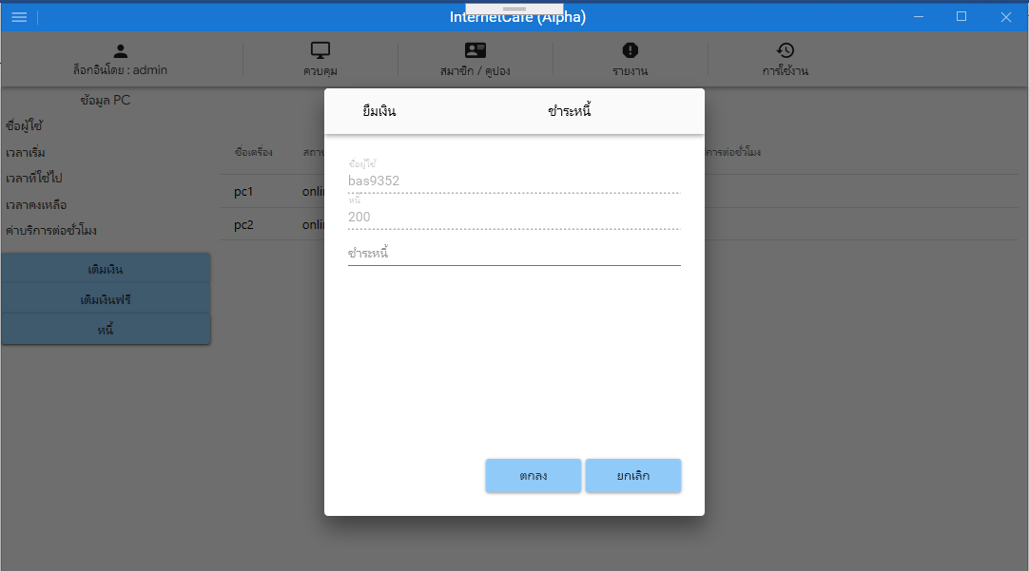

-กรณีไม่ระบุข้อมูลหรือ ระบุข้อมูลไม่ครบ

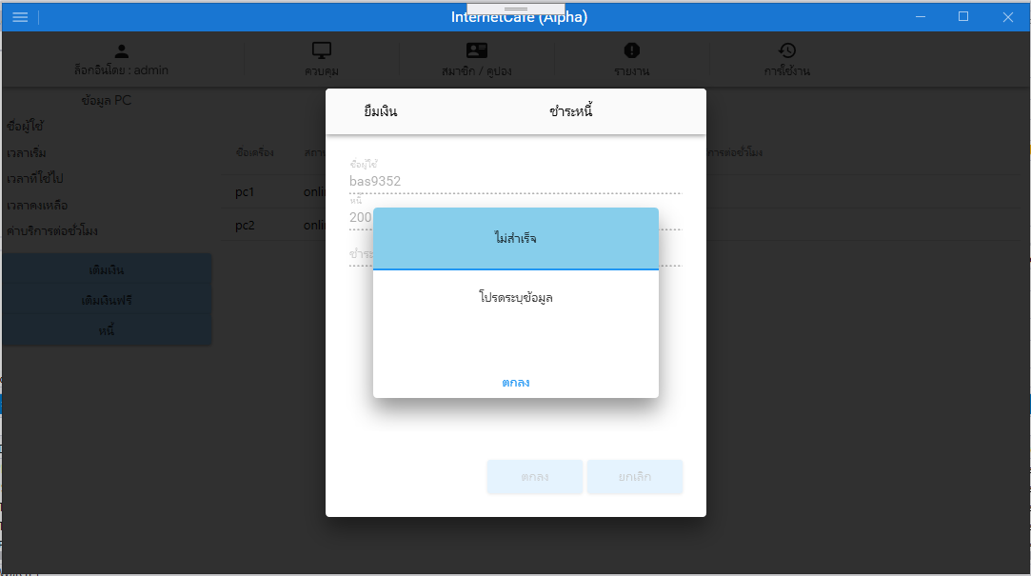

-กรณีการเชื่อมต่อผิดพลาด

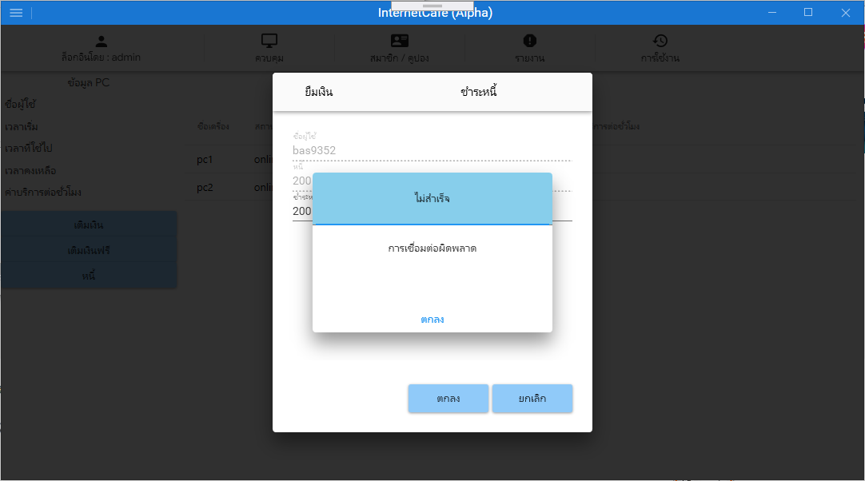

#region Constructor

public PayDebtViewModel()

{

btn_ok = new RelayCommand(p=>

{

grid_p_check = false;

if (txt_pay_debt == null || txt_pay_debt == "")

{

IoC.WarningView.msg_title = GetLocalizedValue<string>("title_false");

IoC.WarningView.msg_text = GetLocalizedValue<string>("enter_info");

DialogHost.Show(new WarningView(), "Msg", ConfirmClosingEventHandler);

}

else

{

if (float.Parse(txt_pay_debt) > float.Parse(txt_debt))

{

IoC.WarningView.msg_title = GetLocalizedValue<string>("title_false");

IoC.WarningView.msg_text = GetLocalizedValue<string>("max_debt");

DialogHost.Show(new WarningView(), "Msg", ConfirmClosingEventHandler);

}

else

{

if (IsInsert() == true)

{

IoC.WarningView.msg_title = GetLocalizedValue<string>("title_success");

IoC.WarningView.msg_text = GetLocalizedValue<string>("add_success");

DialogHost.Show(new WarningView(), "Msg", ExtendedClosingEventHandler);

}

}

}

});

btn_cancel = new RelayCommand(p =>

{

IoC.Application.DialogHostMain = false;

IsClear();

});

}

#endregion

#region Other method

private void ExtendedClosingEventHandler(object sender, DialogClosingEventArgs eventArgs)

{

if ((bool)eventArgs.Parameter == true)

{

grid_p_check = true;

IoC.Application.DialogHostMain = false;

IsClear();

if (IoC.MainView.CurrPage == ApplicationPage.Control)

{

IoC.ControlView.item_online.Execute(IoC.ControlView.online_data);

}

else if (IoC.MainView.CurrPage == ApplicationPage.MemberCoupon)

{

IoC.MemberView.item_member.Execute(IoC.MemberView.member_data);

}

}

}

private void ConfirmClosingEventHandler(object sender, DialogClosingEventArgs eventArgs)

{

if ((bool)eventArgs.Parameter == true)

{

grid_p_check = true;

}

}

public void IsClear()

{

txt_username = null;

txt_debt = null;

member_id = null;

txt_pay_debt = null;

}

public bool IsInsert()

{

string query = $"insert into member_top_up set " +

$"mt_member_id = '{member_id}', " +

$"mt_by = '{IoC.LoginView.login_id}', " +

$"mt_ordinal = '{ordinal + 1}', " +

$"mt_pay_debt = '{txt_pay_debt}', " +

$"mt_date = '{DateTime.Now.ToString("yyyy-MM-dd HH:mm:ss", new CultureInfo("us-US", false))}' ";

try

{

if (OpenConnection() == true)

{

MySqlCommand cmd = new MySqlCommand(query, Sconn.conn);

MySqlDataReader reader = cmd.ExecuteReader();

reader.Close();

Sconn.conn.Close();

return true;

}

else

{

Sconn.conn.Close();

return false;

}

}

catch (MySqlException ex)

{

Sconn.conn.Close();

if (ex.Number == 0)

{

IoC.WarningView.msg_title = GetLocalizedValue<string>("title_false");

IoC.WarningView.msg_text = GetLocalizedValue<string>("conn_unsuccess");

DialogHost.Show(new WarningView(), "Msg");

}

else

{

IoC.WarningView.msg_title = GetLocalizedValue<string>("title_false");

IoC.WarningView.msg_text = GetLocalizedValue<string>("conn_unsuccess");

DialogHost.Show(new WarningView(), "Msg");

}

return false;

}

}

public bool OpenConnection()

{

try

{

Sconn.conn.Open();

return true;

}

catch (MySqlException ex)

{

Sconn.conn.Close();

if (ex.Number == 0)

{

IoC.WarningView.msg_title = GetLocalizedValue<string>("title_false");

IoC.WarningView.msg_text = GetLocalizedValue<string>("conn_unsuccess");

DialogHost.Show(new WarningView(), "Msg");

}

else

{

IoC.WarningView.msg_title = GetLocalizedValue<string>("title_false");

IoC.WarningView.msg_text = GetLocalizedValue<string>("conn_unsuccess");

DialogHost.Show(new WarningView(), "Msg");

}

return false;

}

}

public static T GetLocalizedValue<T>(string key)

{

return LocExtension.GetLocalizedValue<T>(Assembly.GetCallingAssembly().GetName().Name + ":resLang:" + key);

}

#endregion

หน้าสมาชิก และคูปอง

-กรณีทำงานปกติในหน้าสมาชิก

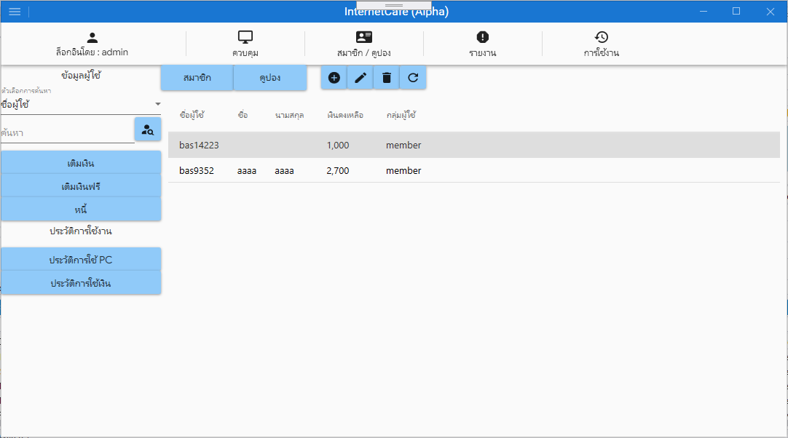

-กรณีทำงานปกติในหน้าคูปอง

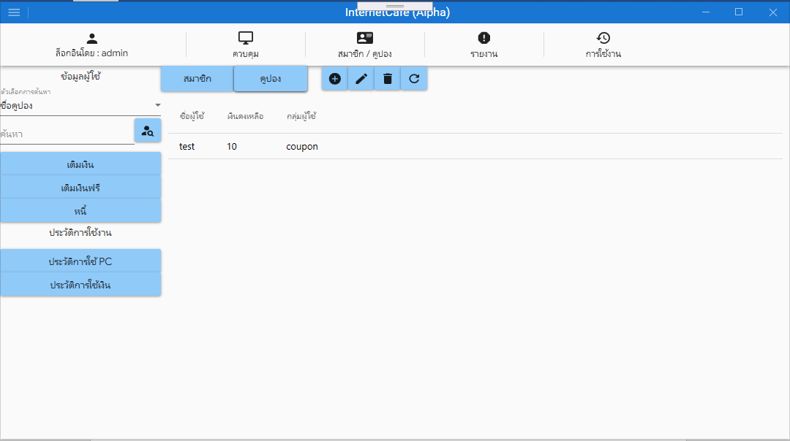

-กรณีการเชื่อมต่อผิดพลาด

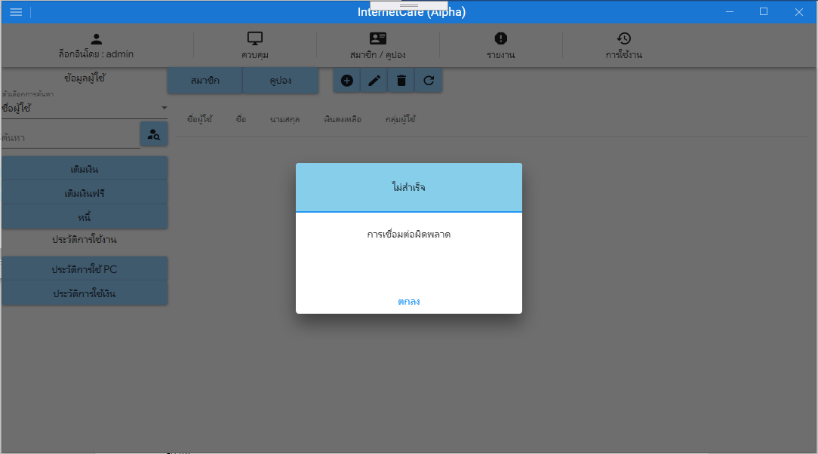

หน้าเพิ่มข้อมูลสมาชิก

-กรณ๊ไม่ระบุข้อมูล

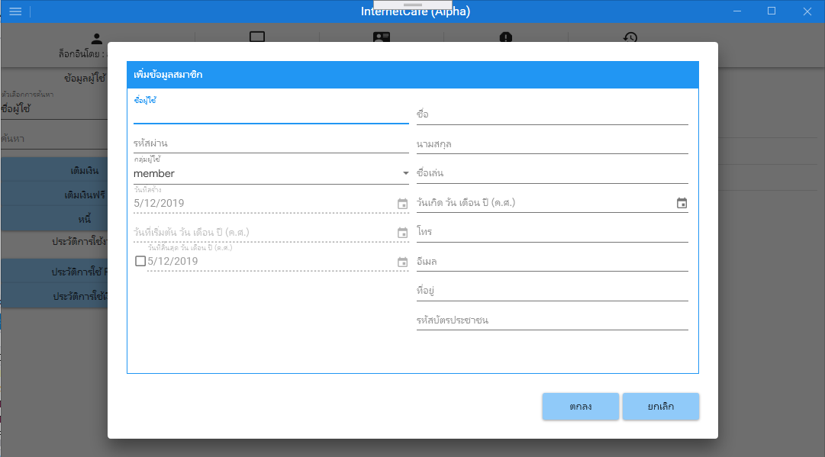

-กรณีไม่ระบุข้อมูล หรือระบุข้อมูลไม่ครบ

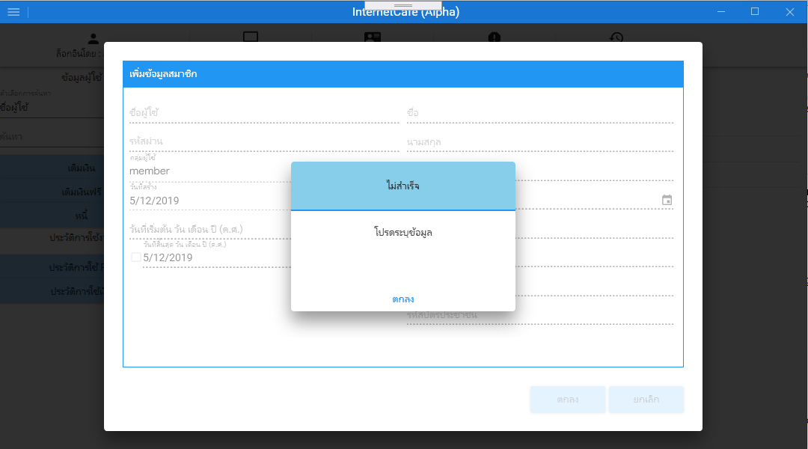

-กรณีมีชื่อผู้ใช้ในระบบแล้ว

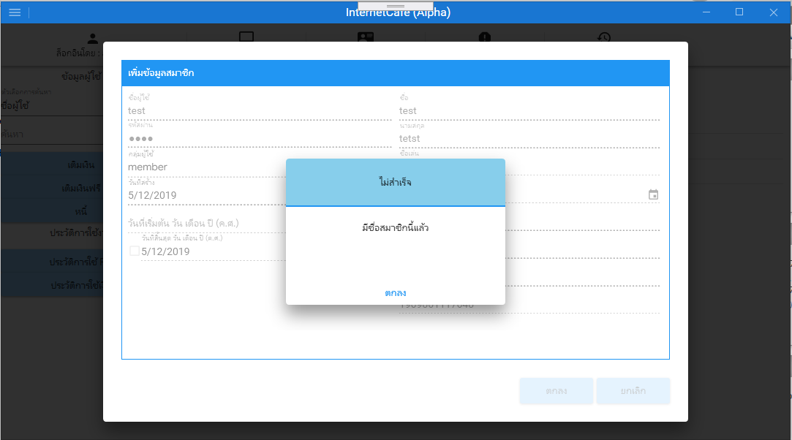

-กรณีการเชื่อมต่อผิดพลาด

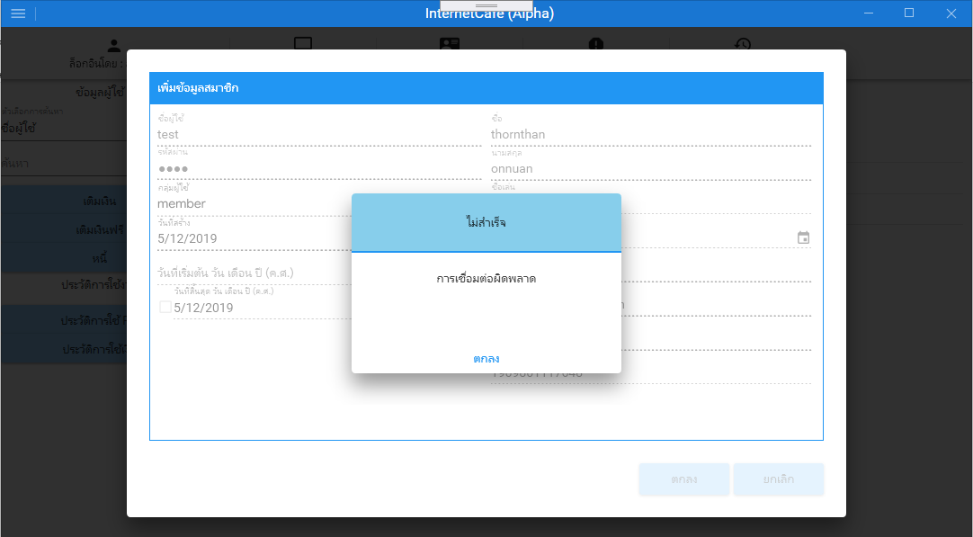

หน้าแก้ไขข้อมูลสมาชิก

-กรณียังไม่ปรับเปลี่ยนข้อมูล

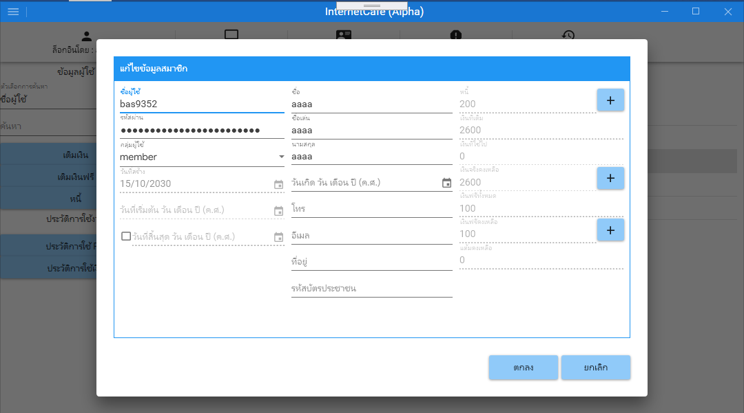

-กรณีไม่ระบุข้อมูล หรือระบุข้อมูลไม่ครบ

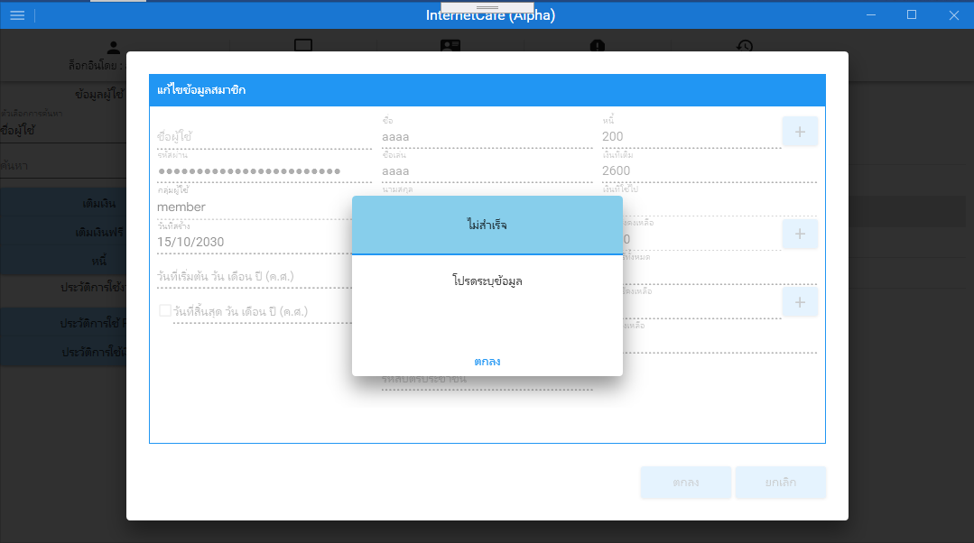

-กรณีมีชื่อผู้ใช้ในระบบแล้ว

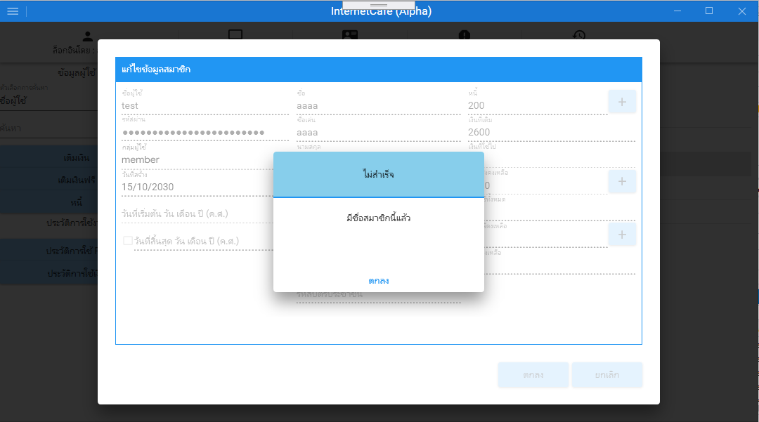

-กรณีการเชื่อมต่อผิดพลาด

